Index

|  |  |  |  |  |  |
| --- | --- | --- | --- | --- | --- |
| S.No | Contents | Page No. | Date | Remarks | Signature |
| 1 | Write a shell script to display 10 numbers it using an array. | 2 | 07-Feb-2022 |  |  |
| 2 | Write a shell script to find out maximum and minimum element from given array of elements. | 3 |  |
| 3 | Write a shell script to display location of an element in an array. | 4 |  |
| 4 | Write a shell script to merge content of two different arrays. | 6 |  |
| 5 | Write a shell script to sort an array of 10 numbers. | 8 |  |
| 6 | Write a shell script to insert & delete from a particular location in an given array of elements. | 9 |  |
| 7 | Write a shell script to delete duplicate elements from a given array of elements. | 11 |  |
| 8 | Write a shell script to display elements of an array in reverse order. | 12 |  |
| 9 | Write a shell script to display the 1st & 2nd element from a given array of elements. | 13 |  |

Lab Assignment 6

# **Ques 1. Write a shell script to display 10 numbers it using an array.**

*#display 10 numbers in array*

for((i=0;i<10;i++))

do

echo "Enter `expr $i + 1` Number"

read arr[$i]

done

echo "Elements of Array"

for((i=0;i<10;i++))

do

echo ${arr[$i]}

done

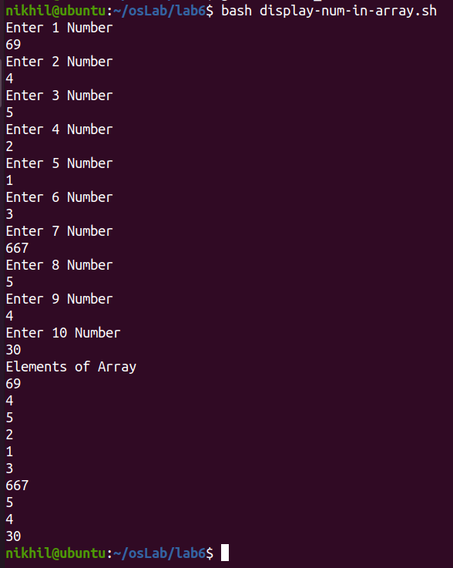

# **Ques 2. Write a shell script to find out maximum and minimum element from given array of elements.**

*#Max and Min Element of Array*

echo "Enter Number of Elements: "

read n

for((i=0;i<n;i++))

do

echo "Enter `expr $i + 1` Number"

read arr[$i]

done

small=${arr[0]}

large=${arr[0]}

for((i=0;i<n;i++))

do

if [ ${arr[$i]} -gt $large ]

then

large=${arr[$i]}

elif [ ${arr[$i]} -lt $small ]

then

small=${arr[$i]}

fi

done

echo "Smallest Element in Array is $small"

echo "Largest Elemnt in Array is $large"

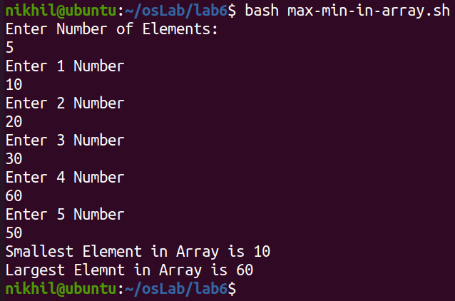

# **Ques 3. Write a shell script to display location of an element in an array.**

*#Find Index of an Array*

echo "Total Number of Lements in Array :"

read n

echo "Enter the elements in the array :"

for ((i = 0; i < n; i++))

do

    read arr[i]

done

echo "Array: "

echo ${arr[*]}

echo "Index of Array to be Updated: "

read loc

echo "Enter your choice : 1.Insert 2.Delete "

read ch

case $ch in

    1)  echo "Enter the element to be entered : "

        read no

        for ((i=n;i>loc;i--))

        do

            arr[i]=${arr[i-1]}

        done

        arr[loc]=$no

        ;;

    2)  for((i=loc;i<n;i++))

        do

            arr[i]=${arr[i+1]}

        done

        n=`expr $n - 1`

        ;;

    *)  echo "Wrong choice !";;

esac

echo "The altered array is : "

echo ${arr[*]}

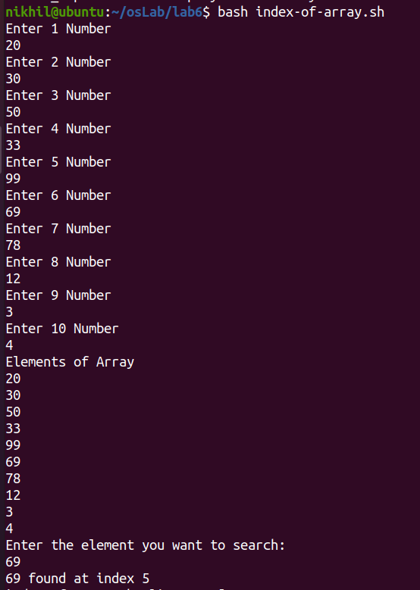

# **Ques 4. Write a shell script to merge content of two different arrays.**

*#Merge two Arrays*

echo "Total Elements in Array 1: "

read n1

echo "Input elements in Array 1 :"

for ((i = 0; i < n1; i++))

do

    read arr1[i]

done

echo "Total Elements in Array 2 :"

read n2

echo "Input Elements in Array 2 :"

for ((i = 0; i < n2; i++))

do

    read arr2[i]

done

k=0

for ((i = 0; i < n1; i++))

do

    arr[k]=${arr1[i]}

    k=`expr $k + 1`

done

for ((i = 0; i < n2; i++))

do

    arr[k]=${arr2[i]}

    k=`expr $k + 1`

done

echo "Merged Array: "

echo ${arr[*]}

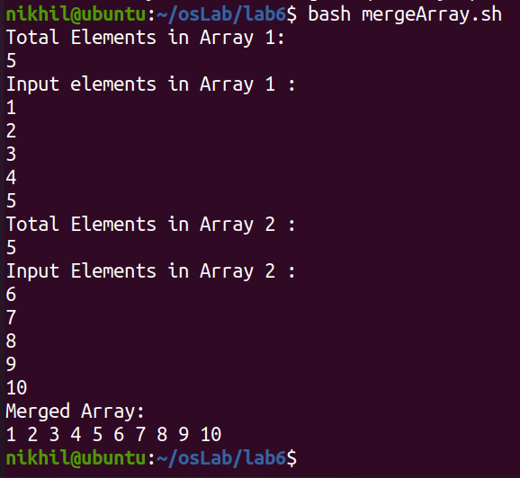

# 

# **Ques 5. Write a shell script to sort an array of 10 numbers.**

*#Sort Elements of Array*

echo "Enter 10 ELements in Array: "

for ((i = 0; i < 10; i++)); do

    read arr[i]

done

echo "The entered array is :"

echo ${arr[*]}

for ((i = 0; i < 10; i++))

do

    for ((j = 0; j < 10-i-1; j++))

    do

        k=`expr $j + 1`

        if [ ${arr[j]} -gt ${arr[k]} ]

        then

            temp=${arr[j]}

            arr[j]=${arr[k]}

            arr[k]=$temp

        fi

    done

done

echo "The sorted array is :"

echo ${arr[*]}

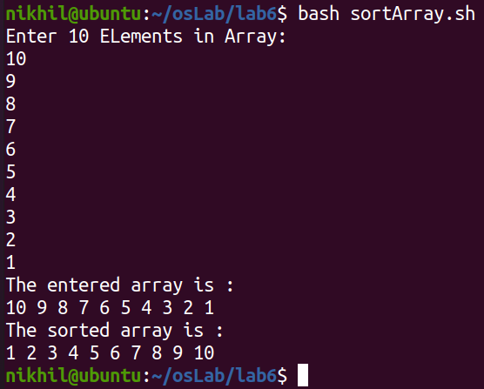

# **Ques 6. Write a shell script to insert & delete from a particular location in an given array of elements.**

*#Insert and Delete from an Array*

echo "Total Number of eLements in Array :"

read n

echo "Enter the elements in the array :"

for ((i = 0; i < n; i++))

do

    read arr[i]

done

echo "Array: "

echo ${arr[*]}

echo "Index of Array to be Updated: "

read loc

echo "Enter your choice : 1.Insert 2.Delete "

read ch

case $ch in

    1)  echo "Enter the element to be entered : "

        read no

        for ((i=n;i>loc;i--))

        do

            arr[i]=${arr[i-1]}

        done

        arr[loc]=$no

        ;;

    2)  for((i=loc;i<n;i++))

        do

            arr[i]=${arr[i+1]}

        done

        n=`expr $n - 1`

        ;;

    *)  echo "Wrong choice !";;

esac

echo "The altered array is : "

echo ${arr[*]}

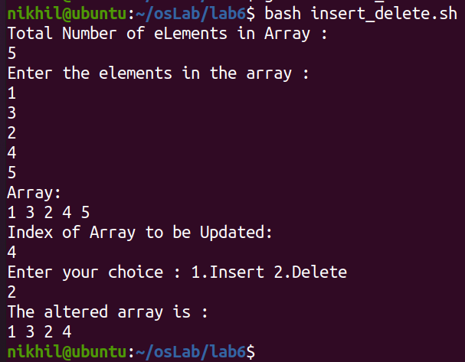

# **Ques 7. Write a shell script to delete duplicate elements from a given array of elements.**

*#Delete Duplicate Element from Array*

echo "Total Number of Elements in Array: "

read n

echo "Enter the $n elements in array :"

for ((i = 0; i < n; i++))

do

    read arr[i]

done

echo "The entered array is : "

echo ${arr[*]}

for ((i = 0; i < n; i++))

do

    for ((j = i+1; j < n; j++))

    do

        if [ ${arr[i]} -eq ${arr[j]} ]

        then

            for((k=j;k<n;k++))

            do

                arr[k]=${arr[k+1]}

            done

            n=`expr $n - 1`

        fi

    done

done

echo "Updated Array: "

echo ${arr[*]}

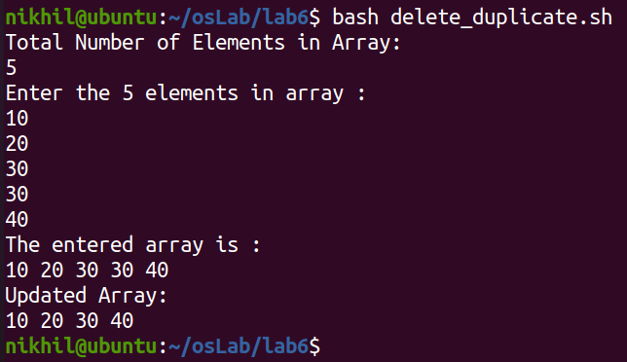

# **Ques 8. Write a shell script to display elements of an array in reverse order.**

*#Reverse Elements of an Array*

echo "Enter Size of Array: "

read n

echo "Enter $n Elements of Array: "

for ((i=0; $i<$n; i++))

do

read a[$i]

done

j=`expr $n - 1`

for ((i=0; $i<$j; i++))

do

temp=${a[$i]}

a[$i]=${a[$j]}

a[$j]=$temp

j=`expr $j - 1`

done

echo "Reversed Array"

for ((i=0; $i<$n; i++))

do

echo ${a[$i]}

done

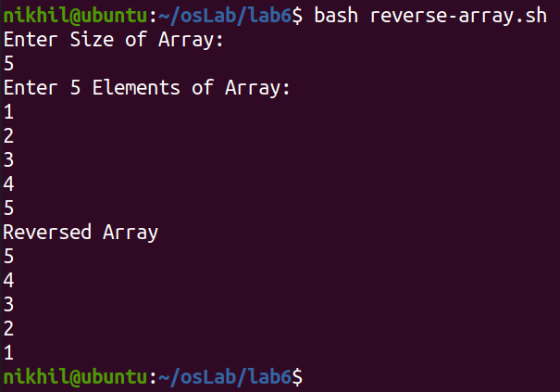

# **Ques 9. Write a shell script to display the 1st & 2nd element from a given array of elements.**

*#Display 1st and 2nd Element from Array*

echo "Enter Size of Array: "

read num

echo "Enter $num Elements in Array: "

for ((i=0; i<num; i++))

do

    read a[i]

done

echo "1st element : ${a[0]}"

echo "2nd element : ${a[1]}"

